Court Side College

BASKETBALL
version 4.1
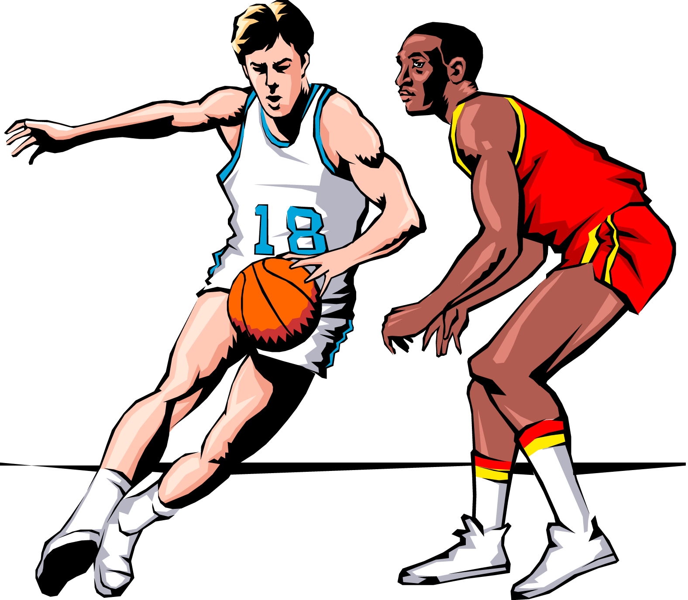

Now all the realism and excitement
of pro basketball in a computer game!

LANCE HAFFNER GAMES

Court Side College Basketball

PLAYING A GAME
Upon typing “P” to play a game, you will immediately be presented with the opening options screen.
(1) Play Mode – by simply hitting “1” you can toggle between Human vs. Human, Human vs. Computer or Computer vs. Computer.
(2 & 3) Team Selection – you will be asked to enter the Disk I.D.. This is usually the last 2 digits of the year for the team you want to play. Example: 92 Temple, you would enter “92”. The Disk I.D. for the “Great Past Teams” included with the game is “GRT”. If you want the same Disk I.D. for both teams, hit <cr> the 2nd time through and the previous Disk I.D. will come up. After you enter the Disk I.D., the teams from that season will appear on the screen. You can use the arrow keys on your keyboard to move up, down, or column to column. The page-up or page-down keys will move back and forth between screens of teams. “Enter” or “Return” selects the team and prompts you for any change.
Disable Players – After team selection, you will be allowed to disabled up to 5 players per team depending on the size of the team’s roster. The players and the number of games played will be displayed on the screen.
To give you an idea of games played by each player, simply hit the number of the player you want to disable. To re-enable the player, simply hit this number again. You must have 8 active players to start a game, so with 10 man teams you will only be allowed to disable 2. (Note: The computer automatically randomly does this, so it is a good idea to go in and check it.
(4) 3 Point Shot – The 3-pointer was officially adopted for the 1987 season. All of our teams from this point forward are rated to shoot three’s. Schools who did not play with the three pointer are not rated for it. Type #4 to toggle it on and off.
(5) Shot Clock- The 45 second clock was officially adopted for the 1986 season. Simply hit “5” to toggle this on and off. Some of the offensive strategies are dependent upon this selection. To use the “Milk the Clock” offensive strategy, you must be using a shot clock.

To use the “Hold Ball” vs. “Passive Zone” which was a popular tactic in the pre-clock era, you cannot be using a shot clock.6) Location – Simply type “6” to toggle this.  (7) Display Pause – This represents the amount of time messages will stay on the screen during play. Experiment based on how fast you read. “0” is the fastest. The higher the number, the longer the text stays on the screen. We use a setting of 1.6. You may put in seconds as well as tenths of a second.  (8) Start Game – When you have all your options set and your teams selected, type “8” to start play.  (9) Fouls to Disqualify – You can type “9” to toggle this between 5 and 6 (some conferences have experimented with 6 fouls during conference play).  (0) Save Settings – Type “0” and the game will permanently save your settings so they will automatically come up each time you play the game.  (A) Free Throws on 10th Foul – Beginning in 1991, two FT’s were awarded on the 10th foul of each half and each succeeding foul. Type “A” to toggle this on or off.  (B) Human Coach – You can toggle this to determine whether as coach you only select lineups and strategy or you can choose to coach and play, in which case you will be able to make shot selections as well.  (C) Shot 3 FTs When Fouled Attempting A Three – From the 1991 season forward, 3 FT s have been awarded when fouled shooting a three. From 1987 – 1990, only 2 FTs were taken in this situation.  (D) 1 FT 1 st 6 Fouls – Prior to the 1973 season, on the first 6 non-shooting fouls of each half, the fouled player attempted 1 FT. From 1973 forward, the rule has been changed so the fouled team simply takes the ball out of bounds.  (E) Commentary – You can toggle the commentary on/off. If you want verbose commentary, a full scrolling description will occur during the game. If you don’t care for this and prefer to play more quickly, then terse commentary will appear in the box. Only the |  | basic information such as the player who has the ball and his shot % will appear.  10 MINUTE TICKER  This feature allows you to simulate playing your game while other games are going on at the same time. The way to utilize this feature is as follows:  (1) Use the auto-schedule feature to schedule up to 32 games. Be sure to put in the starting times of each game. Let the computer play these games without watching the final results.  (2) Put in the starting time of the game that you are going to play. (At least 1 team must be coached by a human).  (3) You can hit “T” at any time during play to display the previously played games in progress. These will be updated about every 4 minutes of playing time. At the end of your game, they will also be displayed as finals regardless of the starting times.  EDIT PLAYER CONTRIBUTION PERCENTAGES  These numbers represent the percent of time a player shoots, rebounds and fouls in relation to the other players on the team. You may change these with this option. In fact, if you want to replay a certain game and have the computer reproduce player usage precisely. You can total up the player’s shots, RB and fouls from the box score. Then take each player’s percentage of the total and input those percentages here.  STARTING LINEUPS  When the computer controls a team, he selects the line-ups. As human coach, you select your line-ups. The 0 and 1 slots are for guards. 2-4 slots are forwards and center. Each team’s roster will be displayed on the screen. Each player is rated for:  FG – 2 point FG %  3FG – 3 point FG %  %3A – The percentage of shots that are 3’s  FT – Free Throw %
ORB – Offensive Rebound Rating  DRB – Defensive Rebound Rating  RB – Total Rebound Rating  PA – Passing rating  S – Steal rating  B – Block rating  CX – Contribution rating (number of times he can shoot, rebound and foul this particular game without his abilities being severely hampered. This will vary from game to game depending on the opponents , numbers of players disabled and your changing of the contribution %)  PT – Points scored (during this game)  F – Fouls (during this game)  FC – Foul Commit Rating  HALF-COURT DEFENSES  SOLID MAN TO MAN – This is the man to man used by most teams. In this defense, your team will allow fewer offensive rebounds. Shot % will be slightly lower with a few easy buckets given up.  PRESSURE MAN TO MAN – In this defense the team tries to pressure the ball and at the same time overplay passing lanes. This defense will create more steals and turnovers. Fouls, offensive rebounds, and easy baskets will increase as well. Three-pointers will be harder to come by. Excessive fatigue may become a problem for the defensive team if this defense is employed for an extended period of time and to some extent, the offense will be affected fatigue wise.  PASSIVE 2-3 ZONE – In this defense, the tempo of the game is slowed. This defense causes less steals and turnovers. Less fouls will be committed in this defense. Blocking out RB’s is most difficult, therefore a few more offensive rebounds will be grabbed. In general, FG% will be a little higher vs. this defense, but easy buckets are harder to come by. Not a good defense against the 3-point shot. If you have players who are excessively fatigued, you can rest them in this defense.  AGGRESSIVE 1-3-1 TRAPPING ZONE– In this defense, the team tries to trap the ball and steal it or force a turnover. Steals and turnovers will increase. Fouls, easy buckets and offensive rebounds |  | will also increase. Excessive fatigue may become a problem for the defensive players.  FULL-COURT PRESSES  FULL-COURT MAN TO MAN PRESS – The purpose of this defense is to slow the pace of the game and work on tiring the opposition’s guards. When this defense is employed, the offensive team will be asked which player he wants to bring the ball up against this press. It is better to choose the player with the highest pass rating. A turnover or steal in the back court here can be disastrous. You need to keep an eye on your guard’s excessive fatigue ratings when facing this press.  FULL-COURT MAN TO MAN (RUN AND JUMP) – This is the all out double team press. You can create a lot of steals and turnovers using this press. You may even force an occasional 10 second violation. When they break this press, easy buckets are quite common. Excessive fatigue can really be a problem if this defense is employed for any length of time.  2-2-1 PASSIVE ZONE PRESS – This is more or less a nuisance press. It will take some time off the clock and cause an occasional turnover or 10 second violation. Excessive fatigue is slight.  1-2-1-1 FULL COURT TRAPPING PRESS – This is the press that made UCLA famous in the 60’s. This press can create a lot more turnovers and steals and can result in easy baskets at either end of the floor. Fouls and excessive fatigue can definitely become a problem for the team using this defense.  MAN TO MAN DENIAL AND FOUL (LAST MINUTES) – You can use this special defense when you are behind in the late stages of the game. It is a desperation defense and will usually result in either a 5 second violation inbounding the ball, steal, foul, or breakaway lay up for the other team.  OFFENSIVE STYLE  Normal – This is the normal offensive pattern for this team.  Aggressive – The offense works extra hard for a really good shot. You will find more above average shots, while turnovers and steals will also increase.
Safe – In this offensive style the primary focus is on avoiding turnovers. However, the shot selection won’t be quite as good either.  Quick Offense (Last 3 Minutes) – Usually employed when you are behind. You need to get shots off more quickly and to do so you will sacrifice shooting accuracy.  Delay Offense (Last 3 Minutes) – Usually employed when ahead. While you are not in a total stall, you are trying to take care of the ball and run some clock. Will still get good shots, just not as frequently.  NOTE: The following offenses, if used excessively, will dramatically alter your team and individual statistics. Never the less, we have included them as coaching options to allow you more diversity in coaching strategy.  Milk Clock to 15 Seconds – You must be using the shot clock. In this defense, the team attempts to take time off the clock each trip down the floor and only looks for a shot during the last 15 seconds.  Stall – Only real good shot – you must be within 10 points of your opponent to use this offense. TO’s and steals will be very few. This is primarily employed occasionally by teams who are facing a vastly superior opponent in hopes of reducing the game to a 21 – 20 type affair that they feel they would have a chance to win.  Total Stall (Last 3 Minutes) – This is the spread or the Carolina 4 Corners. In this you are foresaking all shots and making the defense foul.  Hold Ball vs. Passive Zone – You must be ahead and no shot clock. This was primarily used when a team was ahead and attempted to force a defense out of a passive zone. This offensive strategy more than anything is probably the reason the shot clock was adopted.  NOTE: The defensive coach can hit “D” to come out of the passive zone at anytime if facing this offense or any other stall.  Shoot Only 3-Pointers (Last 3 Minutes) – You can shoot only threes using this strategy in an effort to catch up quickly. |  | CRASHING THE BOARDS  In the last 2 minutes of the game, the computer will allow you to send virtually all 5 players to the offensive boards in a desparate attempt to score. This will increase the chance of a put back basket, but may result in a lay-up at the other end if the other team rebounds.  CONTRIBUTION RATING  Each player has a “CX” rating. This rating will vary depending upon the opponent you are playing. If you are playing Princeton each players’ CX rating will be lower than if you are playing a run’n’gun’ team. The “CX” rating is the number of times that a player can shoot, rebound, or foul during a given game. Each time a player shoots, rebounds or fouls, this CX will be decreased by 1. If the CX gets to 0, then this player will be severely reduced in his shooting, passing, rebounding and defensive skills. During the last 2 minutes of each game and overtimes the “CX” ratings are suspended and players perform to their normal levels of skill. Disabling players at the beginning of the game will also affect CX ratings and you can go into the Change Contribution Percent at the beginning of the game and change the percentage thusly, changing the various CX’s of the players.  EXCESSIVE FATIGUE  The “EF” column reflects each player’s condition during the game. EF becomes a consideration when you employ defenses that make players work harder than normal. These are Pressure M-M, and any of the full court presses. The more aggressive the press, the quicker the EF will go up. When EF reaches 5, the players abilities will be severely curtailed. The offensive players EF will also increase but not as quickly as the defense. When using the M-M press, the guard bringing the ball up the floor will be fatigued more than the other players.  REDUCING EF – Ways to reduce EF are as follows:  1. Play a 2-3 zone. Players will tend to rest due to the nature of this defense
2. Call time out. Players will recover slightly during a time out.  3. Replace a player. If a player rests on the bench for a couple of minutes he will fully recover and his EF will return to 0.  4. Halftime. Players will fully recover during halftime.  TIMEOUTS – While you can substitute, change offensive style and defense during any deadball situation, there are certain advantages to calling timeouts:  1. Occasionally after a time out, the team who called it will experience increased offensive and/or defensive effectiveness.  2. Employing any press will be more effective during a time out than if done on the fly during a deadball situation.  3. Calling a timeout with a player at the foul line has the possibility of actually “ICING” the FT shooter.  Last 5 Seconds Strategy – In a close game when you are behind by 3 or less points with 5 or less seconds left in the game, a special strategy screen will appear on the screen with several options for last second strategy.  Game Play – During regular play, the screen is divided into three parts. The top 1/3 of the screen displays the team names, score, and timeouts. In the center of the screen is the time, half, turnovers, rebounds, total fouls and the shot clock.  The middle third of the screen in the lefthand box displays the commentary. The righthand box displays the defense and offensive style along with several options you can use during play. These options are as follows:  Enter – Pass the ball – This means you want to continue to work for a better shot. When the pass to choice (0-4) comes up you may pass the ball to the player of your choice.  (1) Shoot – This will cause the player to take the shot displayed in the lefthand box. If a star “*” appears after the shot %, this indicates that the shot is “his shot” against the opposing team and should be taken.  (2) Call Time Out – The team in possession of the ball can call |  | timeout.  (T) Ten Minute Ticker – If you have played some games beforehand using the auto schedule and want to check on the progress of these games, this will give you the updated scores screen.  (D) Change Defense from 2-3 Zone – If you are employing a passive 2-3 zone and the other team is using a stall tactic on offense, this key allows you to “come out” of the zone and play a more aggressive defense.  The bottom 1/3 of the screen displays both teams starting line-ups. The following information is displayed for each player.  FG – 2 point FG% (if there is a “*” in front of this number, the player is rated for 3 point shots as well)  FT – Free Throw %  RB – Rebound Rating  CX – Contribution rating. When this rating reaches “0” it will turn red. The player should be replaced until the last 2 minutes of the game.  EF – Excessive fatigue. If this rating reaches “5” it will turn red and the player should be rested.  PA – Pass rating.  PT – Points scored.  F – Fouls.  AUTO SCHEDULER  NOTE: This function will only work if installed to a hard disk because the files it generates excd the space on a floppy disk.  The auto-scheduler allows you to schedule any number of games for the computer to play by itself. Simply input the information required and after the computer has played the games, it compiles the stats and creates the 10 minute ticker files automatically. When it asks you if you want to save this file for future use, you can answer “Y” and save all of the schedule information that you have just entered. This allows you to replay the same set of games later without having to enter all of the information again. Give it a file name such as “UCLA68.SAV” or “KY90.SCH”. The name should be a maximum of 8 characters.  After the auto scheduler has played the games and compiled the
Text |  | Text
Text |  | Text
Text |  | Text

Text |  | Text

Text |  | Text

Text |  | Text

Text |  | Text

Text |  | Text

